A000-AM,S-Peru-Nazca-Uraca Cemetery-Three Entombment Dolls-Textiles-600-1100 CE

**Case no.: Textiles**

**Accession Number:**

**Formal Label:** Nazca-Entombment Doll-600-100 AD/CE AD/CE

**Display Description:** These three dolls may have served in memorial parties or as "companions" for the dead. The coastal areas of Peru and Chile, the jagged slopes of the West Andes, are beneficial for the preservation of textiles. Humidity is the enemy of objects made of vegetable or animal fibers. The West Andes Desert is one of the driest regions in the world. Due to the low air humidity on the coast, many Peruvian textiles have survived. Woven fabrics that have been preserved over the millennia have added much of what we know about the pre-Columbian population of the Andes.

**LC Classification:** F3429.1 A7

**Date or Time Horizon:** Uraca’s artifacts are typical of Middle Horizon sites (around 600 – 1100 AD) in coastal Arequipa, near Toro Muerto.

**Geographical Area:** near the site of Uraca cemetery, located close to Toro Muerto, the immense petroglyph field in Corire.

**Map, GPS coordinates:** -16.19989 -72.55196; 16º11'59.61" S 72º33'7.05" W

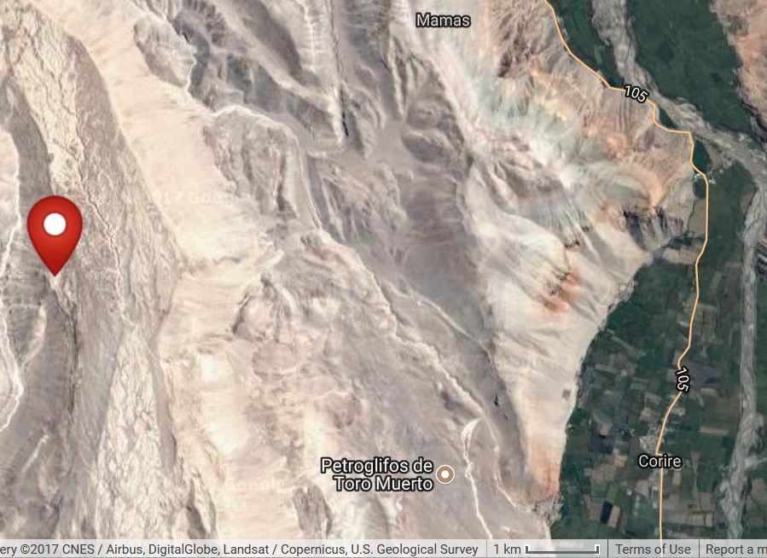

**Fig.** Map of Toro Muerto area, after http://latitude.to/lat/-16.19989/lng/-72.55196

**Cultural Affiliation:** Nazca

**Media:** Native yarns and textiles. It is interesting that some dolls have been found to contain small objects such as spiders and yarns along with the usual stuffing of stiffer vegetable fibers.

**Dimensions:**

**Weight:**

**Condition: original;** a nearly identical copy can be seen at the Narodnu Museum in Prague.

**Provenance:** Arequipa, Peru; then owned by the old Dutch private collection "de Grave".

**Discussion:** The textiles are of chief interest in recovering the processes that the Nazcaa engaged in in looming the fibers from native plants, and dying the fibers in such a way that the colors have remained semi-permanent over the centuries. The filling of the dolls also provides excellent ecological information as to the types of plants that were found in the area during the Middle Horizon sites ca 600-1100 AD/CE.

**References:**

Galdós Rodríguez, Guillermo. 1987. *Comunidades prehispánicas de Arequipa*. Arequipa : Fundación M.J. Bustamante de la Fuente.

Málaga, Eloy Linares. 1990-1992. Prehistoria de Arequipa. [Arequipa : s.n.]

|  |  |
| --- | --- |
|  | Málaga, Eloy Linares. 1995. *Toro muerto : centro ceremonial más grande del mundo con arte rupestre Arequipa – Perú.* Arequipa: Universidad Nacional de San Agustin de Arequipa. |